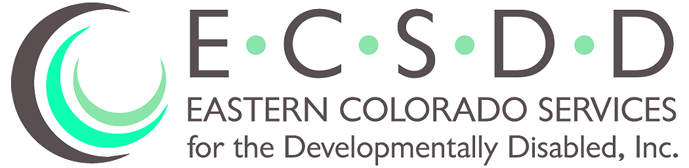
Rhonda L Roth
Executive Director
617 South 10th Avenue • P.O. Box 1682 • Sterling, Colorado 80751-1682
Phone: (970)522-7121 • Fax: (970)522-1173

BOARD OF DIRECTORS MEETING
October 26, 2023

Members Present Members Absent Others Present
Mike Ehrmann Carrie Ankrom Rhonda Roth
Dean Wingfield Ronald Smith Jerri Spear
Kent Jostes (phone) Ronald Berges Leeah Key (phone)
Linda Heller
Tom Timm (phone)
Eva Bruns

ROLL CALL: Mike Ehrmann, President, called the meeting to order. A quorum was present.

PUBLIC COMMENTS: None

EXECUTIVE SESSION: Executive Session was called at 6:40 pm for staffing discussion. It was adjourned at 6:53 pm.

APPROVAL OF MINUTES: Motion was made with second: (Jostes/Timm) to approve the September 28, 2023 Minutes. All in favor; none opposed. Motion carried.

AGENDA ADDITIONS/UPDATES: None

CORRESPONDENCE: None

FINANCIAL REPORT: The July 2023 financial report was presented by Director Roth. We did see a profit of $56,457. This was the first month for the 2023/2024 fiscal year 3% rate increases.

OLD BUSINESS:

Case Management Redesign CMRD:
- We are continuing to meet regularly with NECALG to prepare for the Case Management transition by March 1, 2024.
- We received verbal notification that we are going to receive the HCPF Technology Grant that we applied for to assist in digitization and electronic data transfer of our Case Management records to NECALG and an upgrade of Sandata, our current client management system.

Board of Director’s Meeting
DATE: October 26, 2023
Page 2

NEW BUSINESS:

Wells-Fargo Bank: We received notice recently from Wells Fargo that our bank account had been compromised and our account information was being sold on the dark web. It was discovered that a couple of our checks mailed to a vendor in another state had been stolen and were cashed. A hold had to be placed on our account and closely monitored since we had a large number of vendor payment checks that still needed to be cashed. Based on this issue, we have transferred our money sooner than planned to the Bank of Colorado.

Years of Service Celebration: Following the Board meeting an individual recognition and reception was held for long-term employees and their families.

MEETING ADJOURNED
Next Board meeting is December 7, 2023, at 6:30pm
617 S 10th Ave, Sterling
Telephone conference number is 571-748-4021
and the Participant Pass Code is 8798724, followed by the # sign.

