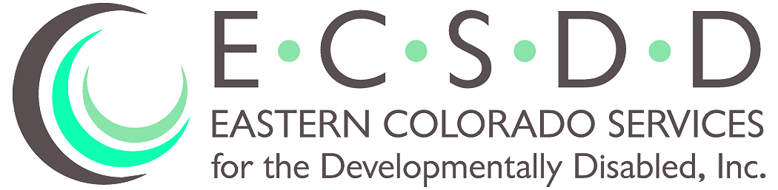
Rhonda L Roth
Executive Director
617 South 10th Avenue • P.O. Box 1682 • Sterling, Colorado 80751-1682
Phone: (970)522-7121 • Fax: (970)522-1173

BOARD OF DIRECTORS MEETING
July 28 , 2022

Members Present Members Absent Others Present
Mike Ehrmann Gordon Westhoff Rhonda Roth
Eva Bruns (Phone) Linda Heller Leeah Key
Dean Wingfield (Phone) Kasha Sheets
Tom Timm (Phone)
Ronald Smith (Phone)
Mark Turner (Phone)
Kent Jostes (Phone)

ROLL CALL: Michael Ehrmann, President, called the meeting to order. A quorum was present.

PUBLIC COMMENTS: None

EXECUTIVE SESSION: Executive Session was called at 6:36pm to discuss personnel issues. Dismissed at 6:44pm

APPROVAL OF MINUTES: Motion was made with second: (Ehrmann/Bruns) to approve the June 30, 2022, Minutes. All in favor; none opposed. Motion carried.

AGENDA ADDITIONS/UPDATES:
- Director’s Evaluation to be moved to the August agenda. The documents and request for input to all Board Member will be resent.
- Addition of approval for additional operation under Fiscal Year 2022-2023’s budget.

CORRESPONDENCE: The verbal and written staff thank you notes for the financial gifts for Fair were relayed to the Board.

FINANCIAL REPORT: The June financial report was not presented and will be included in the fall audit presentation. Motion was made with second: (Bruns/Wingfield) for approval to operate on the 2022-2023 budget for one more month. All in favor; none opposed. Motion carried.

Board of Director’s Meeting
DATE: July 28, 2022
Page 2

OLD BUSINESS:
- The sale of the Gayle Street residence in Fort Morgan is on schedule and should be done by mid- August.

NEW BUSINESS:
- The Case Management Redesign process was discussed by Director Roth who has spoken with the State appointed Change Agent Coach, Mary Lou Bourne. Ms. Bourne is also working with the Single-Entry Point (SEP) provider, NECALG in Fort Morgan. Due to the complexity of this State required process, Ms. Bourne has planned a presentation for the Board on August 18 at 6:00 pm. Subsequently, we are requesting to change the August meeting date to the same date at 6:30 pm instead of the previously scheduled August 25th meeting. Motion was made with second: (Bruns/Turner) to approve Board Meeting change from August 25 to August 18, 2022. All in favor; none opposed. Motion carried.

- Per the recent State Supported Living Services (SLS) survey, ECSDD is missing a monitoring piece in our policy. The policy was rewritten and has already received State approval. The policy was reviewed by the Board for approval. Motion was made with second: ( Ehrmann/Bruns) to approve the presented policy with the following corrections: spelling error on page 1, HCBS acronym, and correction on page 4 of “by the”. All in favor; none opposed. Motion carried.

EXECUTIVE DIRECTOR UPDATE: None

MEETING ADJOURNED.

Next Board meeting is August 18, 2022, with a Case Management Redesign presentation at 6:00 followed by regular Board meeting at 6:30 pm.
(PLEASE NOTE THE MEETING DATE and TIME CHANGE)
Log in instructions for the Case Management presentation will be sent in a separate email
The 6:30 meeting telephone conference number is 1-877-820-7831 and the Participant Pass Code is 8058169, followed by the # sign.

